HR Analytics: Employee Attrition Analysis

1. Project Overview
This project analyzes employee attrition patterns using HR dataset to identify key factors influencing workforce turnover. The objective is to understand why employees leave the organization and to provide data-driven insights that help HR teams improve retention strategies.
The project integrates Python for data cleaning, PostgreSQL for structured business analysis, and Power BI for interactive dashboard visualization.

2. Dataset Summary
- Rows: 1,470 employees
- Columns: 30+ features
- Key Features:
  - Employee demographics (Age, Gender, Marital Status)
  - Job-related details (Department, Job Role, Job Level)
  - Compensation data (Monthly Income, Salary Band)
  - Experience metrics (Years at Company, Years Since Last Promotion)
  - Work patterns (Overtime, Work-Life Balance)
  - Target variable: Attrition
- Missing Data: No major missing values after cleaning
- Attrition converted to numeric format (1 = Left, 0 = Stayed)

3. Exploratory Data Analysis using Python
Data cleaning and preprocessing steps:
● Data Loading using pandas
● Initial Exploration: Used df.info() to check structure and .describe() for summary statistics
● Removed unnecessary columns (StandardHours, Over18, EmployeeNumber)
● Converted Attrition into numeric format (attrition_flag: 1/0)
● Created new features:
- Salary Band (Low / Medium / High)
- Tenure Group (0–2, 3–5, 6–10, 10+ years)
● Checked for null values and ensured data consistency
● Exported cleaned dataset to PostgreSQL for SQL analysis

4. Data Analysis using SQL (Business Insights)
Business questions answered using PostgreSQL:
1.What is the overall attrition rate?
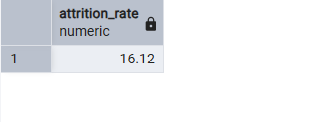
2. Which department has the highest attrition?
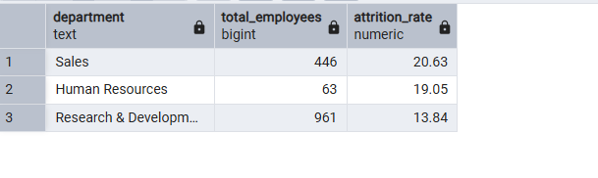
3. Does overtime increase attrition?
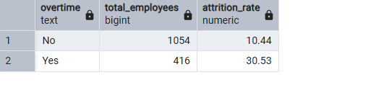
4. Which salary band has the highest attrition?
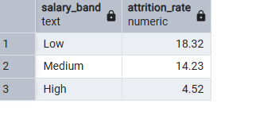
5. Does tenure affect attrition?
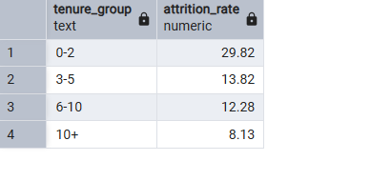
6. Which job roles are high-risk?
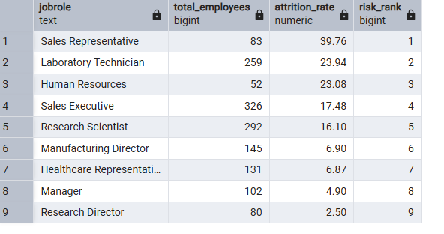
7. Is there a gender difference in attrition?
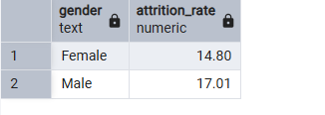
8. Does marital status influence attrition?
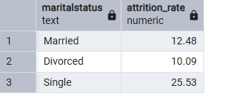
9. What is the average salary of employees who left?
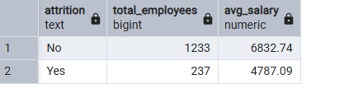
10. Does lack of promotion (3+ years) increase attrition?
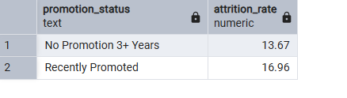

5. Dashboard in Power BI
An interactive one-page dashboard was developed including:

KPI Cards:
- Total Employees
- Employees Left
- Attrition Rate (%)
- Average Salary
- Average Years at Company

Visualizations:
- Attrition by Department
- Attrition by Salary Band
- Overtime vs Attrition
- Attrition by Tenure Group
- Attrition by Job Role

Interactive Features:
- Department slicer
- Gender slicer
- Salary Band slicer
- Job Role slicer
- Dynamic KPI updates
The dashboard allows management to filter and analyze high-risk employee segments dynamically

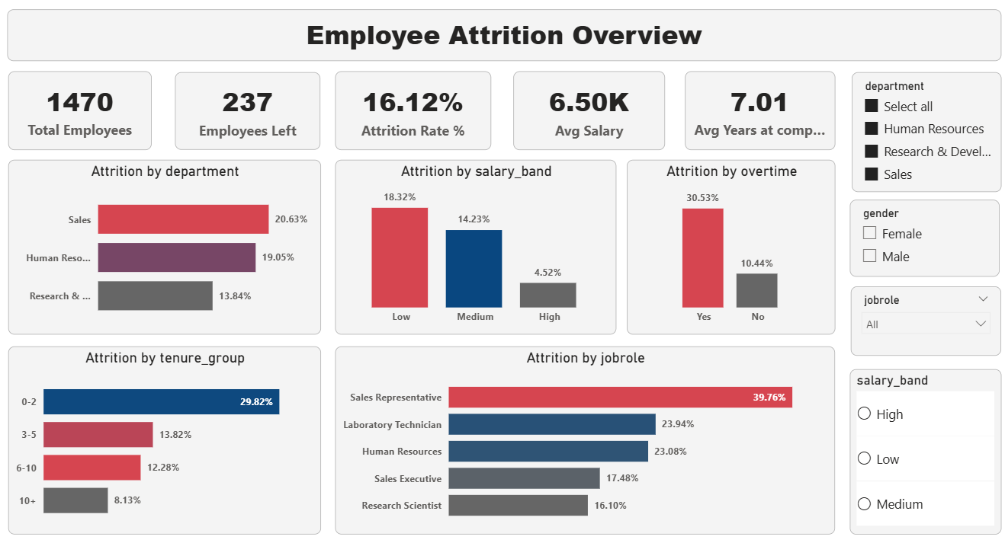

6. Key Insights
- Employees in the Low Salary Band show significantly higher attrition.
- Overtime employees are more likely to leave.
- Sales department contributes highest to total attrition.
- Employees without promotion for 3+ years show increased exit rates.
- Certain job roles have consistently high attrition risk.

7. Business Recommendations
● Improve compensation structure for low salary band employees
● Monitor overtime workload to prevent burnout
● Design targeted retention strategies for high-risk departments
● Implement promotion review policies for employees with long stagnation
● Introduce employee engagement and career development programs

8. Conclusion
This HR Analytics project demonstrates how data-driven analysis can help organizations understand employee attrition patterns. By combining Python, SQL, and Power BI, actionable insights were generated to support strategic HR decision-making and workforce retention planning.

